Dear Parent,
We’re excited to share that scheduling your child’s visits just got a lot easier! Beginning today, all ABCD New Braunfels (on Stephens Place) patients can schedule a sick or well visit via the Patient Portal. All that is required is a Healow Patient Portal username and password. If you have not registered for the Patient Portal, please inquire with the medical receptionist at check in during your next visit.

To schedule a visit using online scheduling, the patient or guardian will follow the steps below.

Click here to be taken to the patient portal log in page.

If you do have an account, click View your Health record to log in.
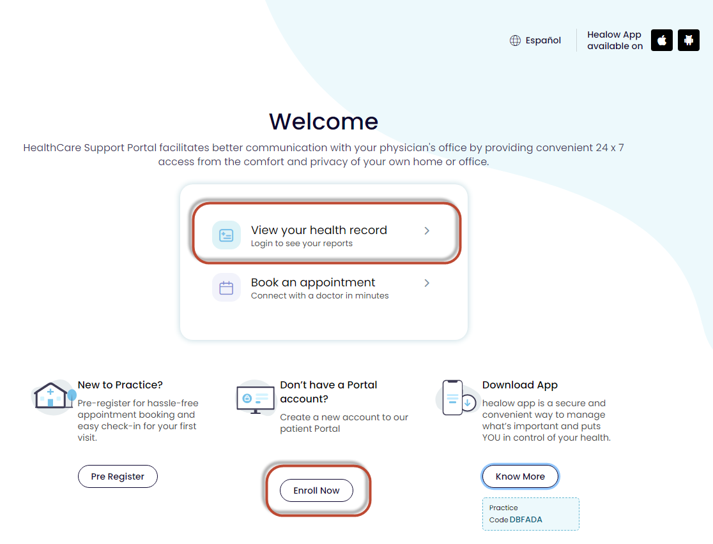

A log in screen displays. Enter the Healow Patient Portal username and password, or select the option to log in using your mobile phone.
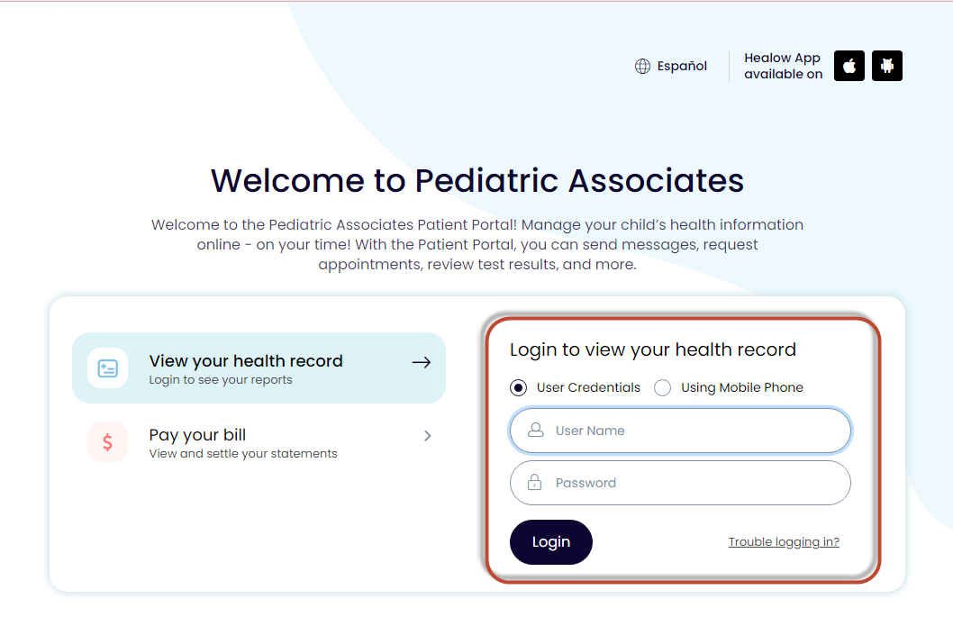

The patient is now logged into the portal.
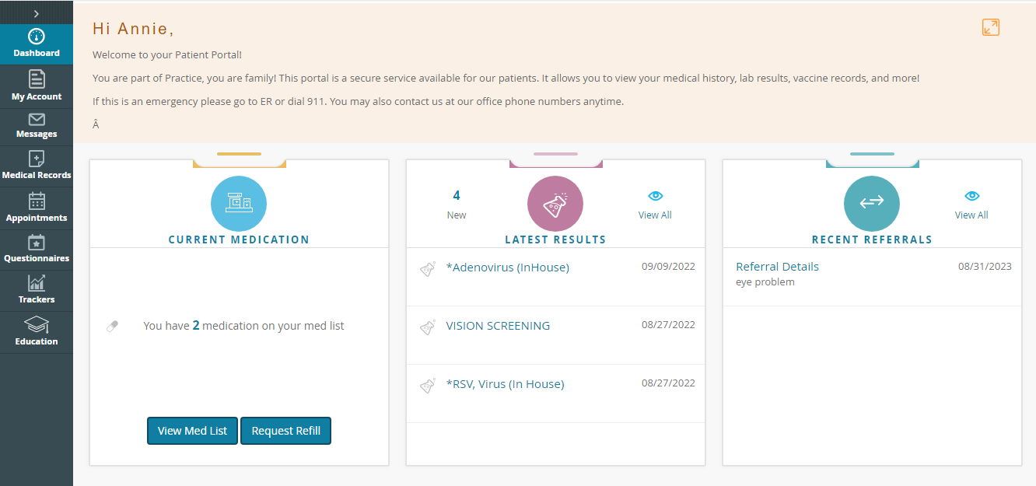

Click Appointments, and select New appointment.
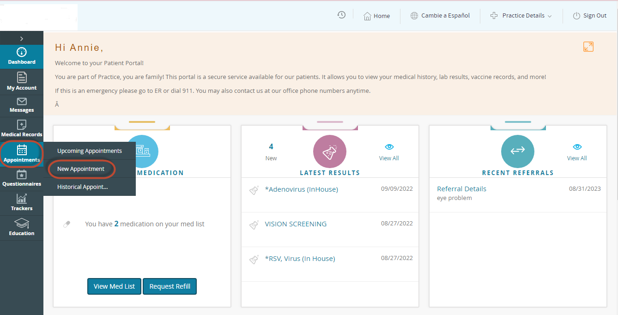

Choose a visit reason and a location. Click Search.
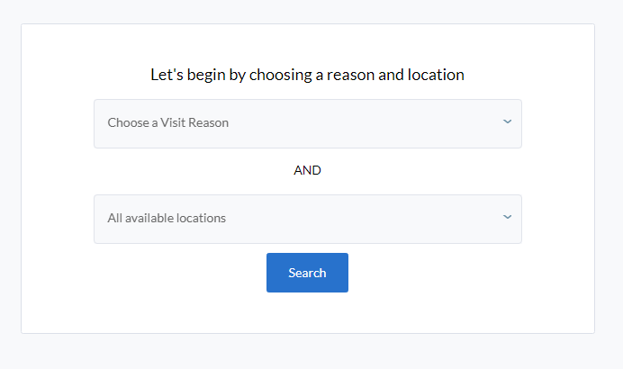
Available clinicians at the facility will display, along with a map. Click Show Availabilities.
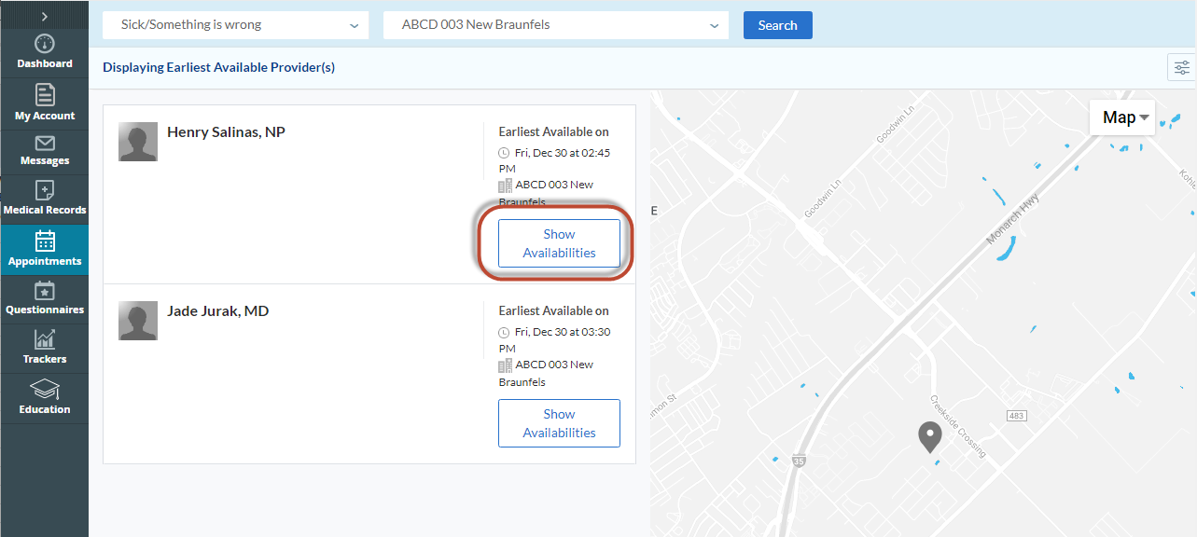

Available times will display. Choose one.
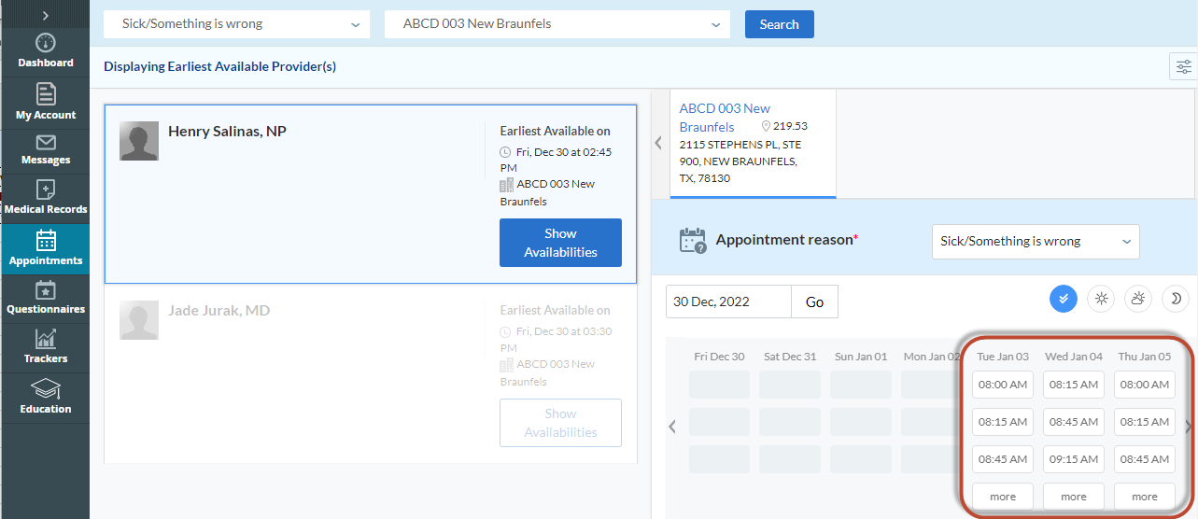

An Appointment Details screen displays.
In the box called Info for the Provider, provide a brief description as to why you need to be seen, then click Continue.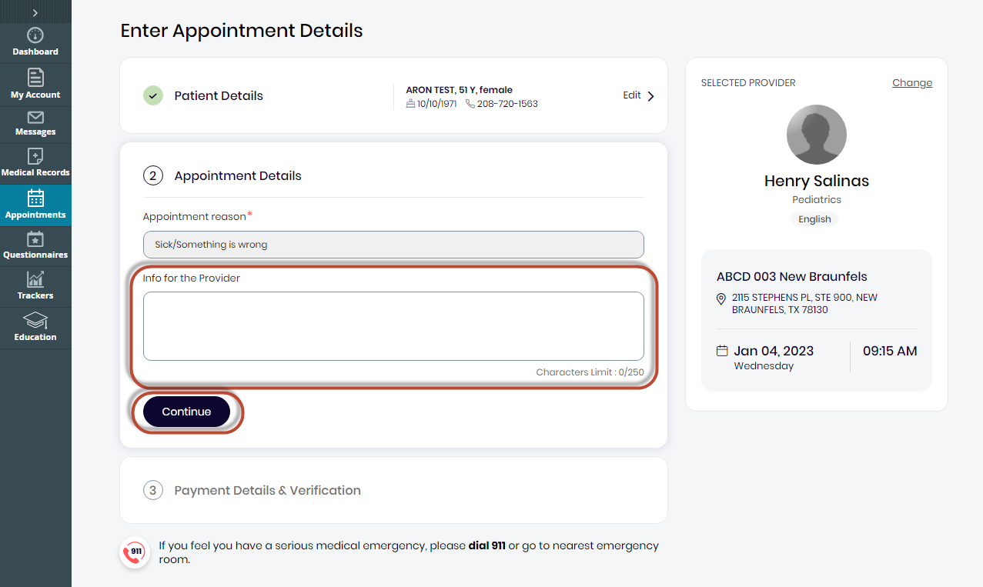

Next, you will need to specify how you would like to pay.
After that, you will need to verify the phone number, either with a text message or a phone call (using the phone number we have on file for the patient). Choose either Text or Voice, and click Send.
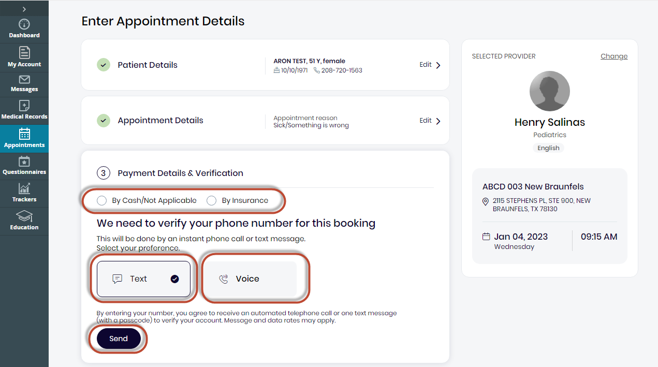

Enter the code that was provided to you
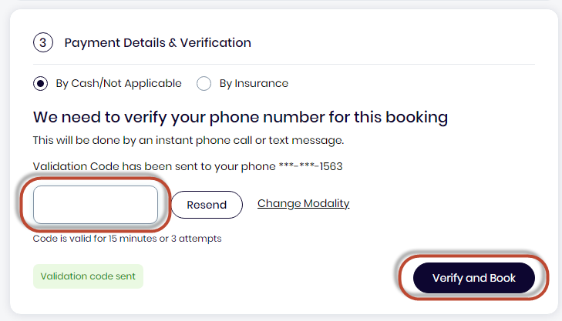

A confirmation that the appointment that has been scheduled will display.
